

**Handyman Application USER GUIDE**

12. 2019

Version 10.12



COMP-213-006, Software Project Development, Team-1

Centennial College, Fall-2019.



**USER GUIDE**

**Handyman Application**

Handyman -in-Publication Data

Contents: User’s manual. Software manual

ISBN 9XX 92 4 150019 XX

© HANDYMAN, Centennial College, COMP231- fall 2019

All rights reserved. Publications of the Handyman, Centennial College can be obtained from Centennial college library, Centennial college, Progress Campus, e-mail: laibrarycentennialcollege@centennialcollege.ca. Requests for permission to reproduce or translate Handyman publications – whether for sale or for noncommercial distribution – should be addressed to Imtiaz Ahmed, COMP231, at the above address e-mail: ikhan91@my.centennialcollege.ca

All reasonable precautions have been taken by the Team-1 to verify the information contained in this publication.

However, the published material is being distributed without warranty of any kind.

Design & Layout: Imitaz Ahmed, Software Engineering, Centennial College, Prgress Campus, Toronto,Canada.

12/2019

#### How to use this manual

* Handyman application control center information
* Get Started three common buttons

# Homeowner

* Member Registration (Homeowner)
* Log in as Homeowner.
* Search for a Handyman
* Book a Handyman
* Dashboard – List current jobs

# Handyman

* Member Registration (Handyman)
* Set availability
* Log in as a handy man
* Get Notification for a job
* Dashboard – List current jobs

Common question and Answer

Contents

About the Handyman application 7

GET Started 7

Know Your Buttons: Sign-up 7

Know Your Buttons: Sign In 8

Know Your Buttons: Get Started 8

**Homeowner** 9

How to Registration as a Homeowner? 9

How to Log-in as a Homeowner? 11

How to hire a Handyman? 13

How to search a Handyman? 17

**Handyman** 17

How to Registration as Handyman? 17

How can I log in Handyman Application as a handyman? 21

How I know my booking Notification? 22

Does handyman get Notification in email, too? 23

Question and Answers 24

1. How handy man application protect consumer rights if any handy man neglected a job after booking? 24

2. Can I hire a handy man when I log in as a handyman? 24

Appendices 25

Index 25

# About the Handyman application

Handyman (version 2.12) is a windows-based software application which is a platform for both homeowner and handyman. Handyman application very easy to operate as graphical user interface design is very simple. You need basic computer operating skills to operate our application. Toronto is mostly a migrant city where peoples are from various countries and languages ever year and housing is one of the main basic needs in our daily life. To make life easy, we bring **HANDYMAN application** to market.

Any kinds of job or project now you can do with help of our application. Just log to our website, then register, search and booked a handy man. No Job done left.

If you are a handyman looking for jobs, just register your information with valid email address and check your email notification time to time. You will automatically be informed when someone booked you by automatically email system.

We ensure all our handyman are evaluated when they sign up to provide great quality for our clients.

Control center of HANDYMAN application:

# GET Started

1. Know Your Buttons:

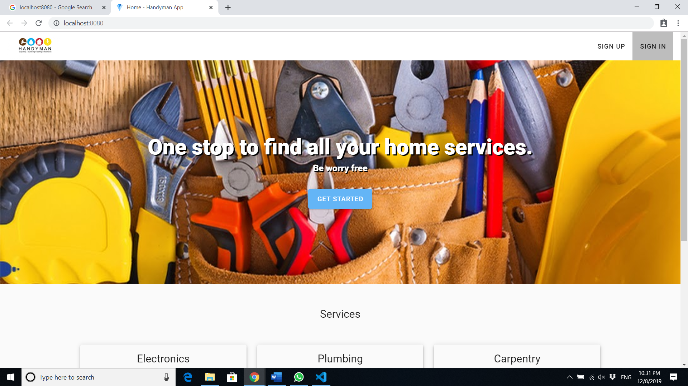

GET STARTED

Sign Up button

Sign In button

Fig: Handy man Application Control center

# Know Your Buttons: Sign-up

Sign Up

To get maximum advantages of our application, click this signup button and a new window will appear where user can consider as homeowner, or as a handyman group. Every user must have to sign up first as a homeowner or a handyman.

# 

# Fig: select group

# Know Your Buttons: Sign In

# 

Sign In

Sign in button is used for starting your account by giving right username and password that you send our database during your sign-up (registration) process. After giving right username and password -> then click sign in button. A new screen called “dashboard” will appear. Where you can see all your booked appointment with handy man. Or if you are a handy man, you will see all handyman list. You also can hair a handy man to finish your job done on time.

# Know Your Buttons: Get Started

Get Started

Get started button is the button that is you start our application to do everything. After clicking it, a new window will appear, where you can select log-in or sign-up from here too. If you click log-in, then log-in window will appear where you put your username and password. And log to our system.

If you click sign-up, then a new window appears where you select as handy man or a home owner, click “homeowner” or “handyman” which one is appropriate for you. Then another window call create profile a new window will appear. Put your all the required information and click Next button,

Another new window will appear, where user need to put his/her email, username, and password, then click submit button. A new window will appear call registration successful, click on DONE button. You will back tohome screen dashboard. Enjoy your browsing our application. Good Luck.

# **Homeowner**

# How to Registration as a Homeowner?

1. Click on the button. After clicking it, a new window will appear,

Get Started

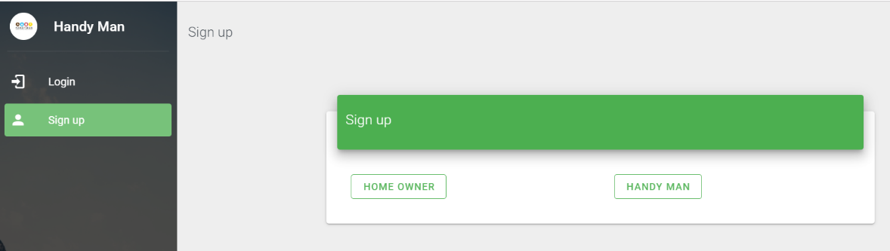

Fig 1.2: Signup screen

1. Click on the Home owner Button. A new window will appear called “Create Profile”. Input all the required information. Please You must have to put your ZIPCODE for localization identification.

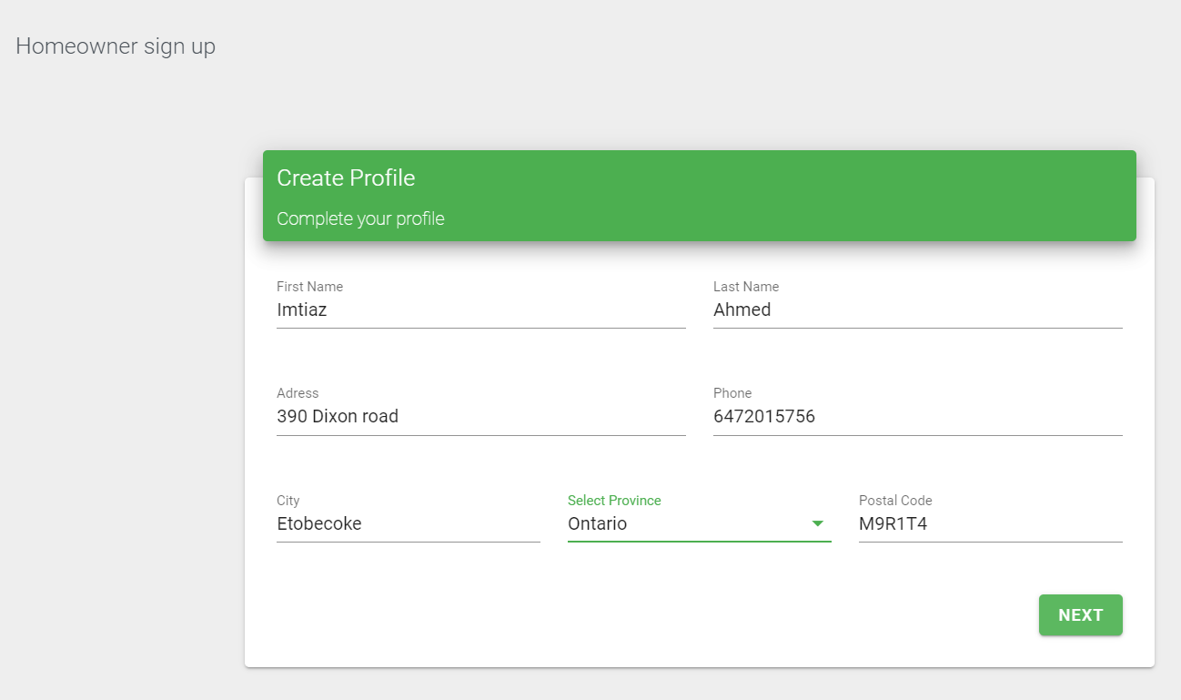

Fig:1.3 Create Profile Windows

Then click the NEXT button.

1. A new window will appear (Fig:1.4). User select your username which must be at list 4 character long and your valid email address where all the notification and the used for further communication with our system and handy man. Finally, a password. You can take a picture of this screen in your hand phone for future reference as everything you start our application you need this information.

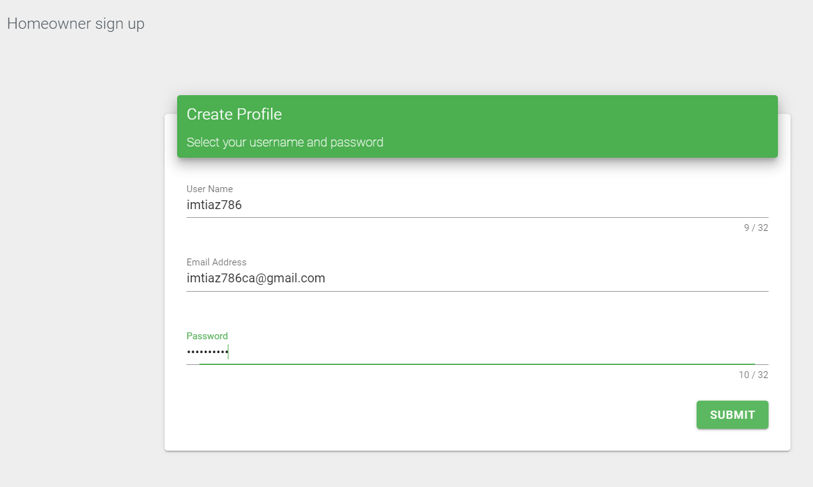

Fig: 1.4 Username and Password

And click SUBMIT button.

1. A new window will appear call registration successful, click on DONE button. Your registration is done. It will take you our home screen.

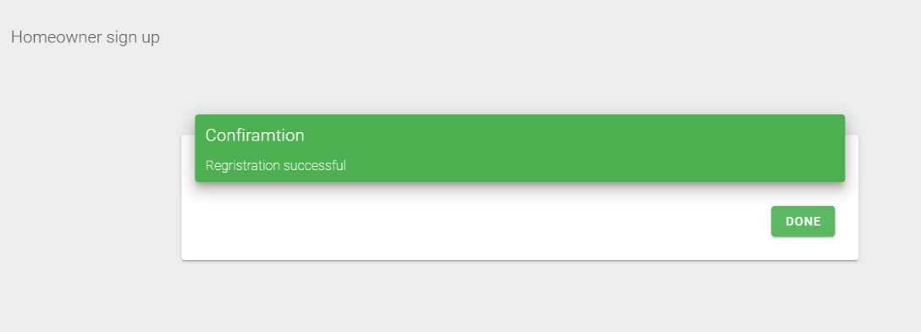

Fig: 1.5 Confirmation (registration successful)

1. You will back to home screen dashboard. Enjoy your browsing our application. Good Luck.



Fig 1.6 Home Screen of Handyman Application

# How to Log-in as a Homeowner?

Get Started

1. Click on then a window will appear,

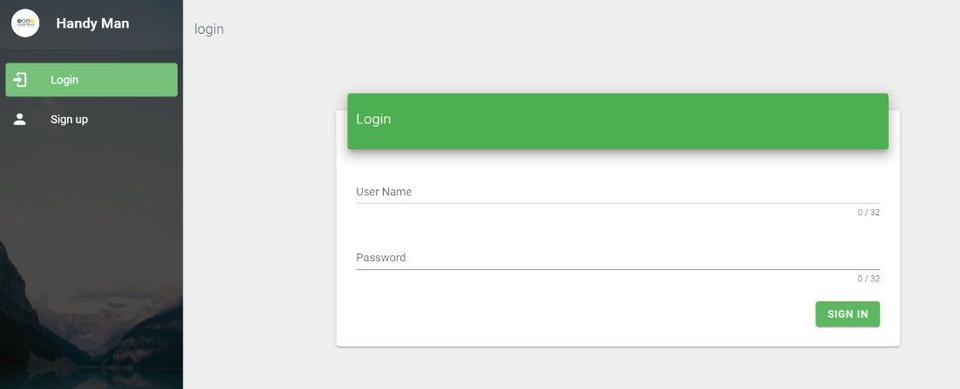

Fig: 2.1 Log In

1. Insert your username and password and click in sign-in Button. A new window will appear called Dashboard where you can do rest of your search works for handy man.

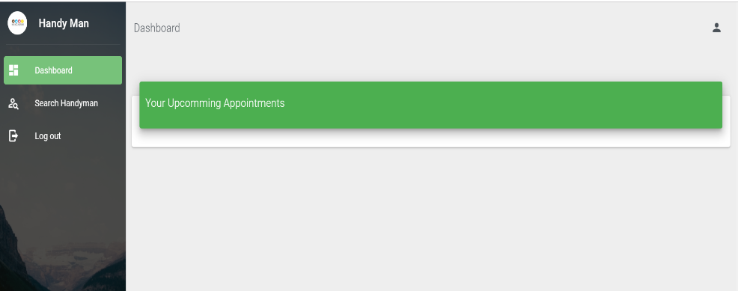

Fig 2.2 Your Upcoming Appointment

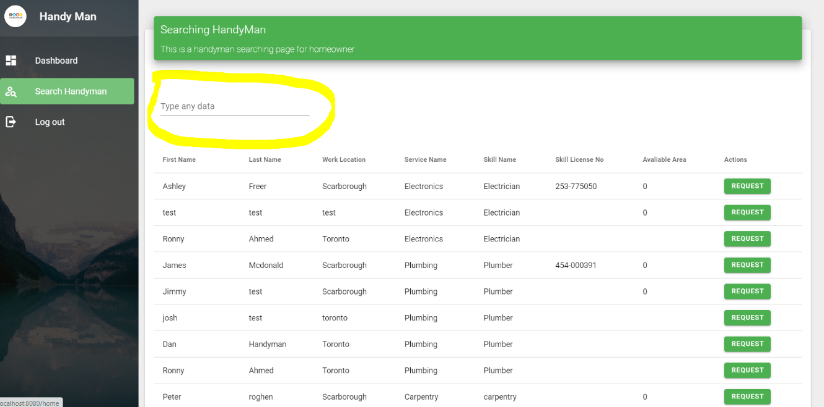

Fig 2.3 Lookup handy man list

You can browse handy man list by 10- 15 line per page or by all in one list.

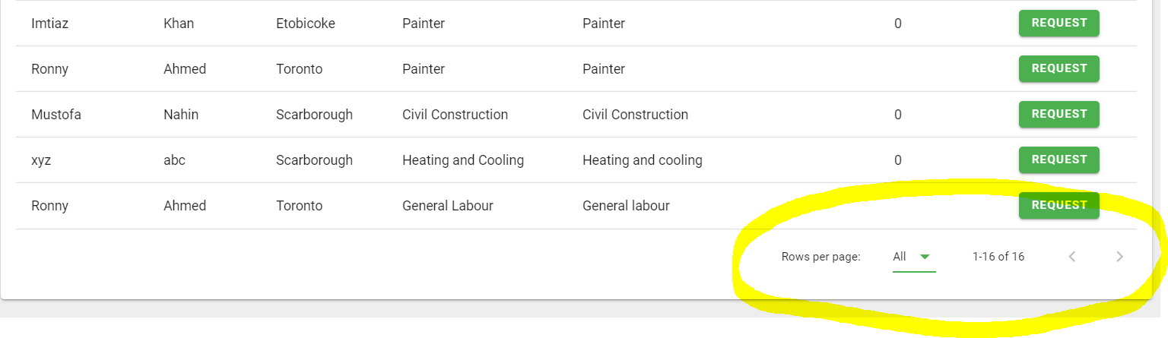

Fig 2.4 searching for a painter handyman

1. Finally, click log-out button after finishing your work.

# How to hire a Handyman?

1. Log to your account (follow previous steps)
2. Click Search handyman tab left side of the screen.



Fig 3.1 List of handy man

1. Type a field name for example; type painter all painter will appear.

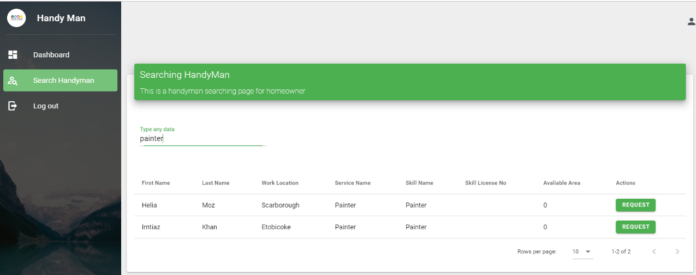

Fig: 3.2 Searching a painter

1. Click on the Request Button on the right Side of the list .

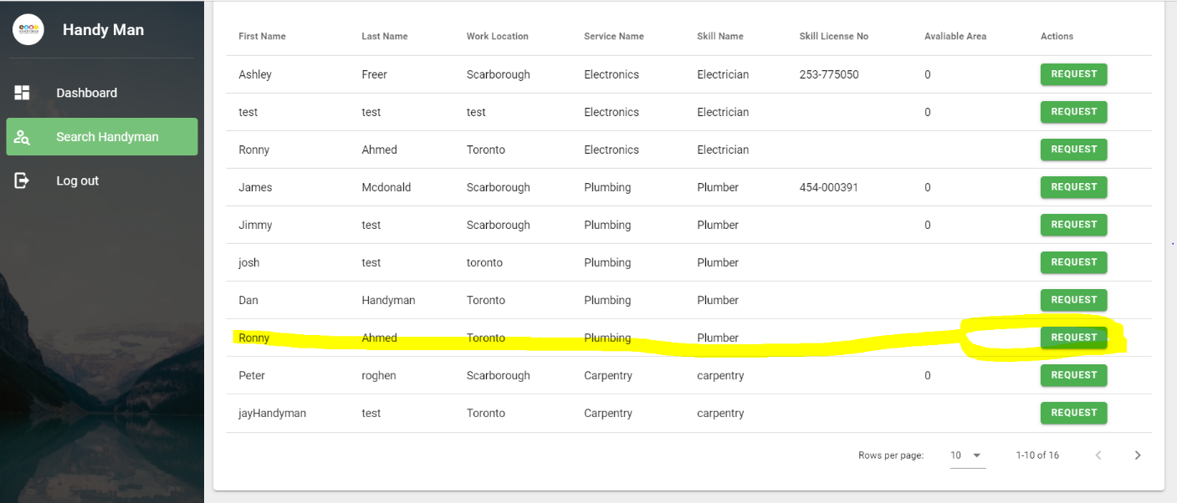

Fig 3.3 Click Request button

1. A new window appears called Verify booking details

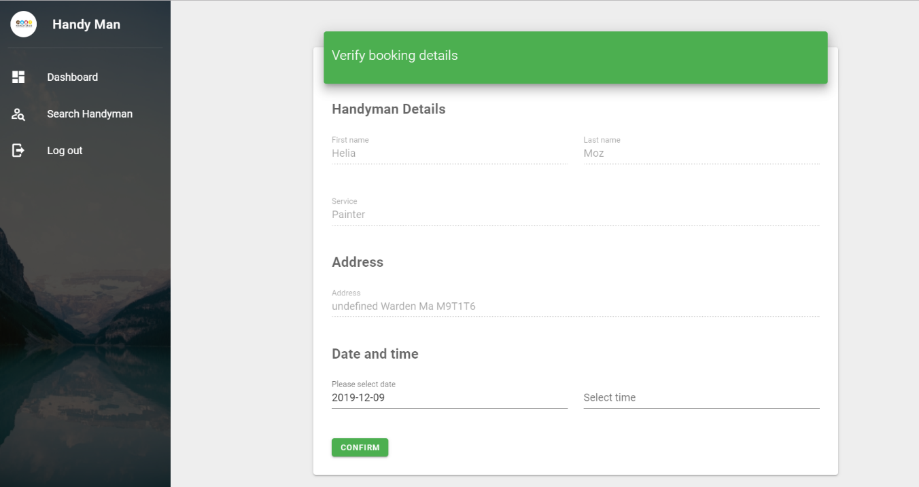

Fig: 3.4 Verify Boking a Handyman

1. Click on the date and time tab a calendar will appear, select the date or month from that calendar.

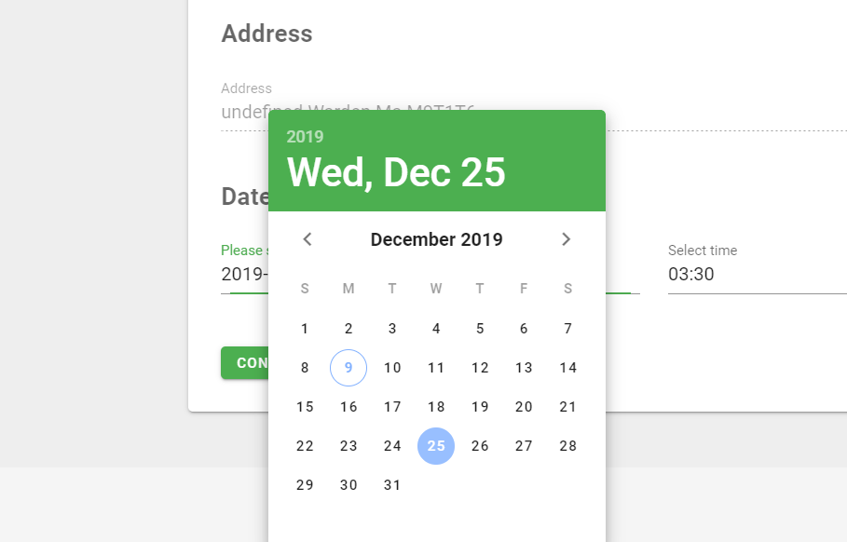

Fig 3.5 Select Date

1. Then Click On time option. A clock will appear, select the hour from the dial, then select the min.by mouse pointe freely.

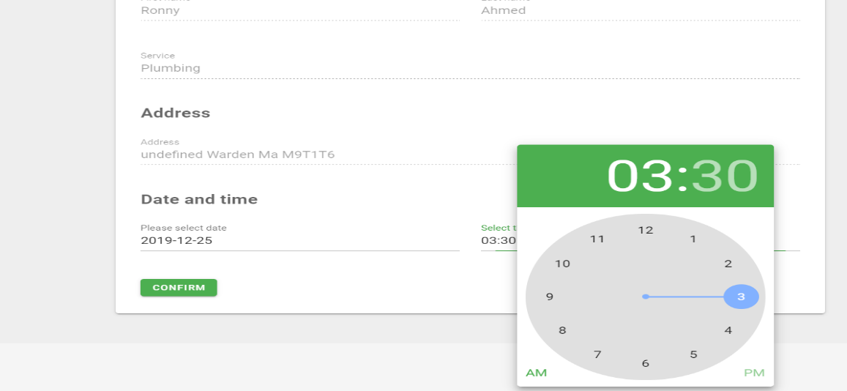

Fig 3.6 Select Time

1. Finally. Click the on confirm button. A booking Confirmed window will appear.

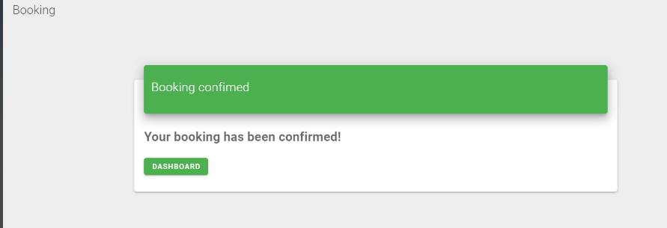

Fig: 3.7 Booking Confirmation

1. You will receive an email notification in your email address. Where everything describes details.

Date, time, Service, name and phone number.

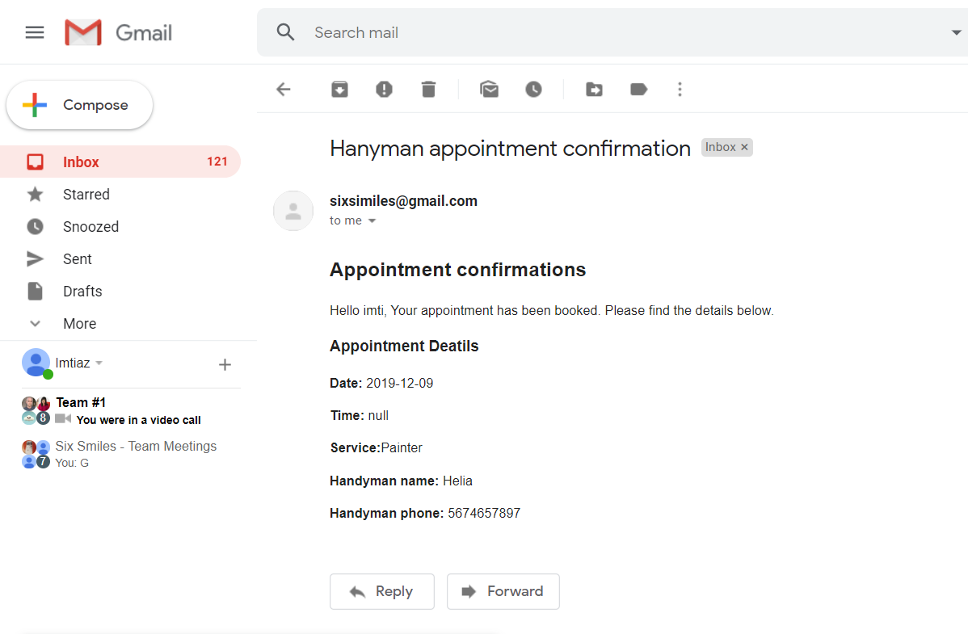

Fig :3.7 Email notification of Booking a painter named Helia.

Now you are done. Wait for the date and time to meet a handy man. No worries. No job undone.

1. At the same time handy man will received a booking information to her email.

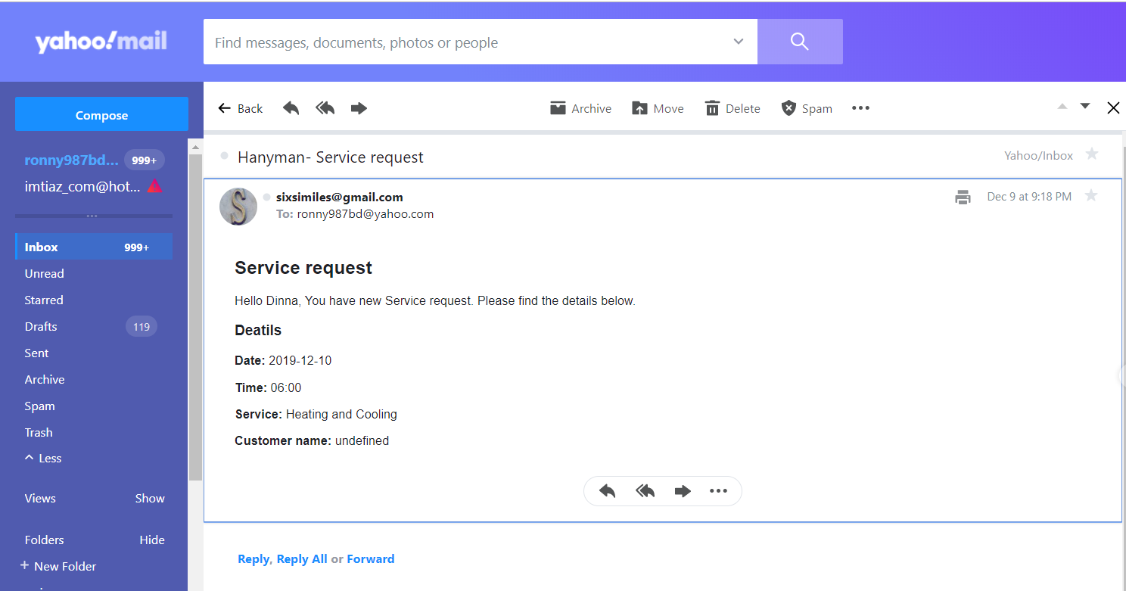

Fig: 3.8 handyman booking notification.

# How to search a Handyman?

1. Log to system as a homeowner by following steps (fig:2.1) then click on search handy man from the left side of the screen. A list of all different handy man will appear select as your need.

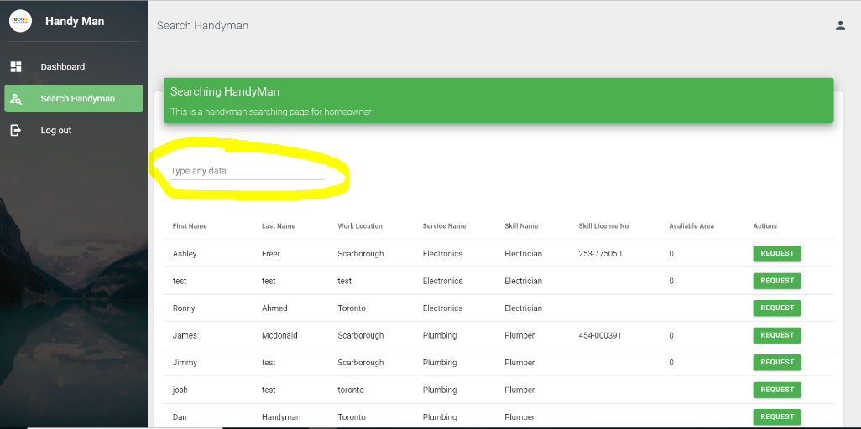

Fig4.1 Search Handyman by any find.

1. Type any key word you want to search. For example; first name, last name, skill name, work location any key word.
2. After your first search log out and login-in for the next search. For better search result.

# **Handyman**

# How to Registration as Handyman?

1. Click on the button. After clicking it, a new window will appear,

Get Started

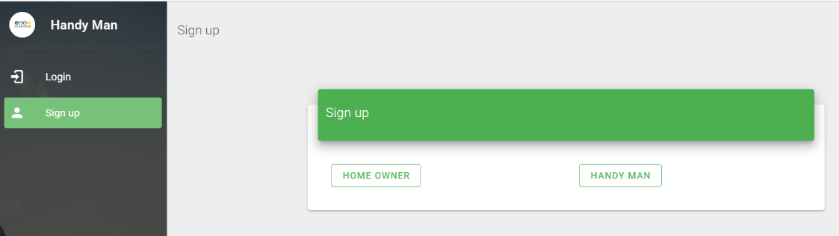

Fig 5.1 Signup screen

1. Click on the Handyman Button. A new window will appear called “Create Profile”. Input all the required information. Please You must have to put your ZIPCODE for localization identification.

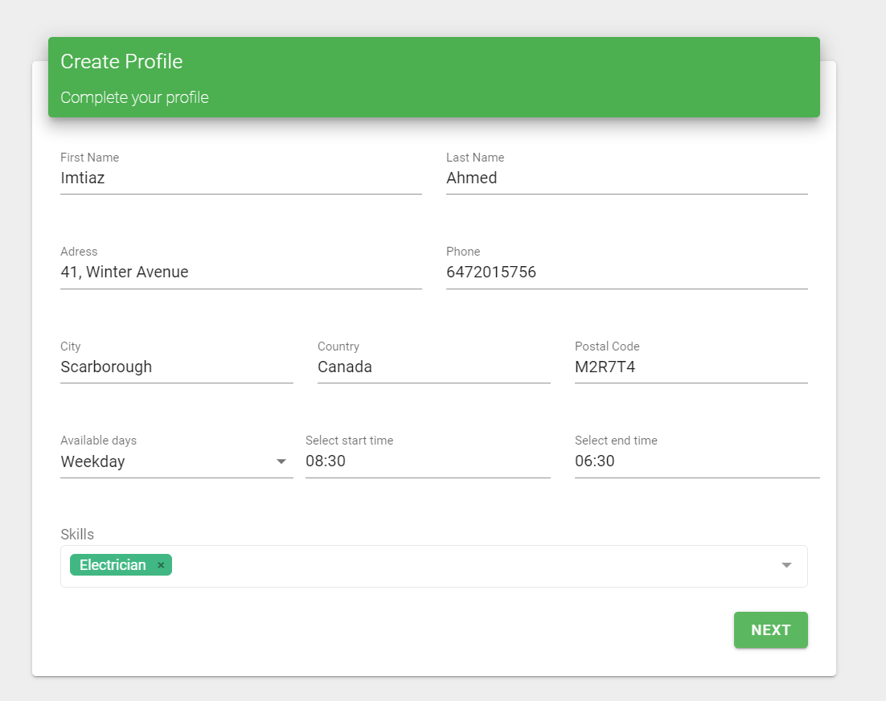

Fig 5.2 Create Profile Screen

Available day there 3 type, it is pull down menu, select your time

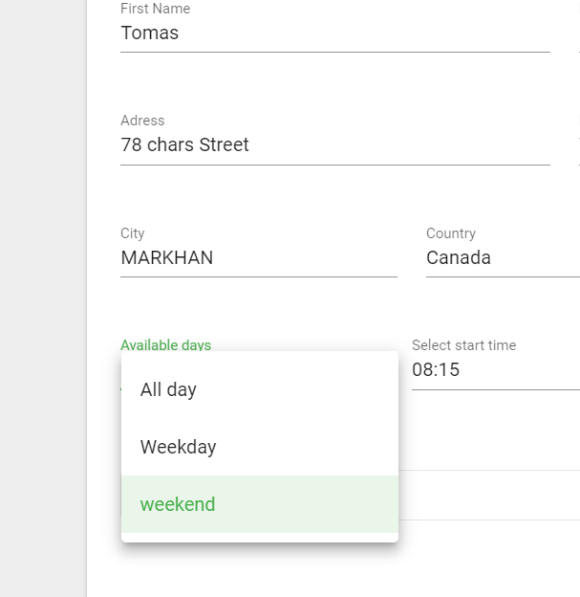

Fig 5.3 Available days

1. For working hour 2different clock 24hour diagram will appear, one for hour and next scale is for after 12:00 it will count 13:00, 14:00 to 24:00. Select mouse pointer freely rotted arrow.

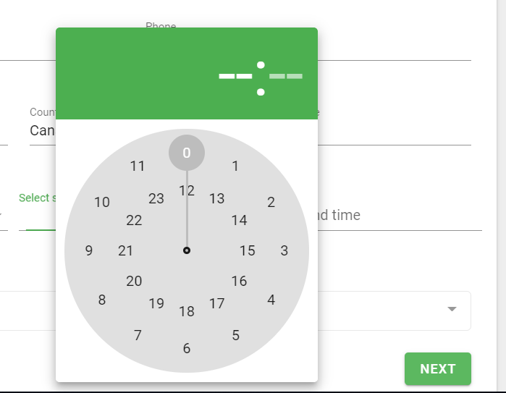

Fig 5.4 Select working hour

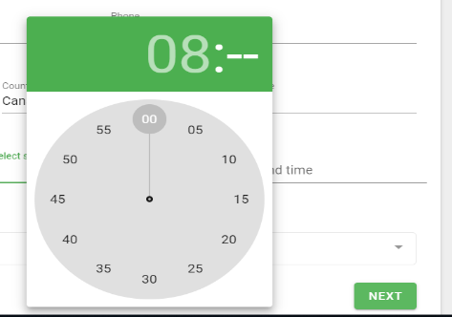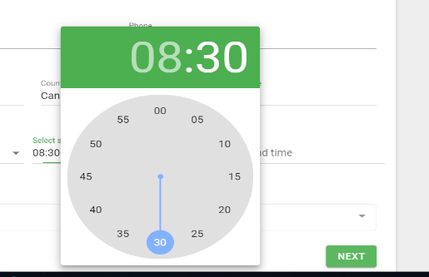

Fig 5.5 How to select time

1. Click Select Stop/ Clossing time. To calculate AM/PM 5pm = 17(12+5) showing 30min dail.

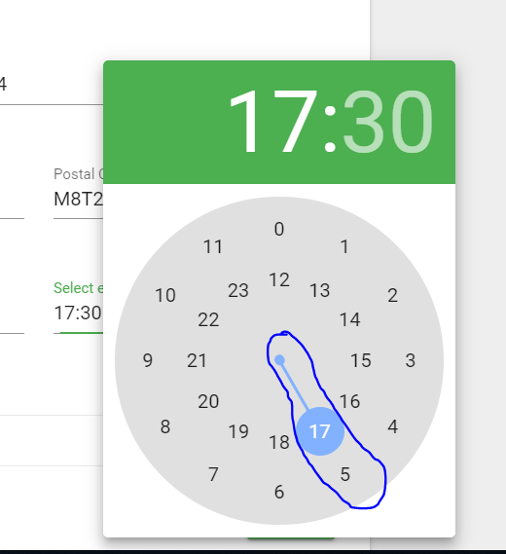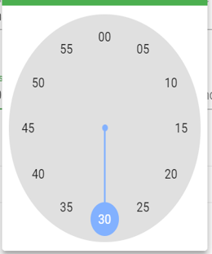

Fig 5.6 Showing 24 hour’s clock where (5:00 = 17:00 ) Select the closing time

1. Click Next button, A new window will appear where User Name, (at list 4 character long), A valid Email address, and a password, you can take a picture for future information. You should not share this information to others for security concern.

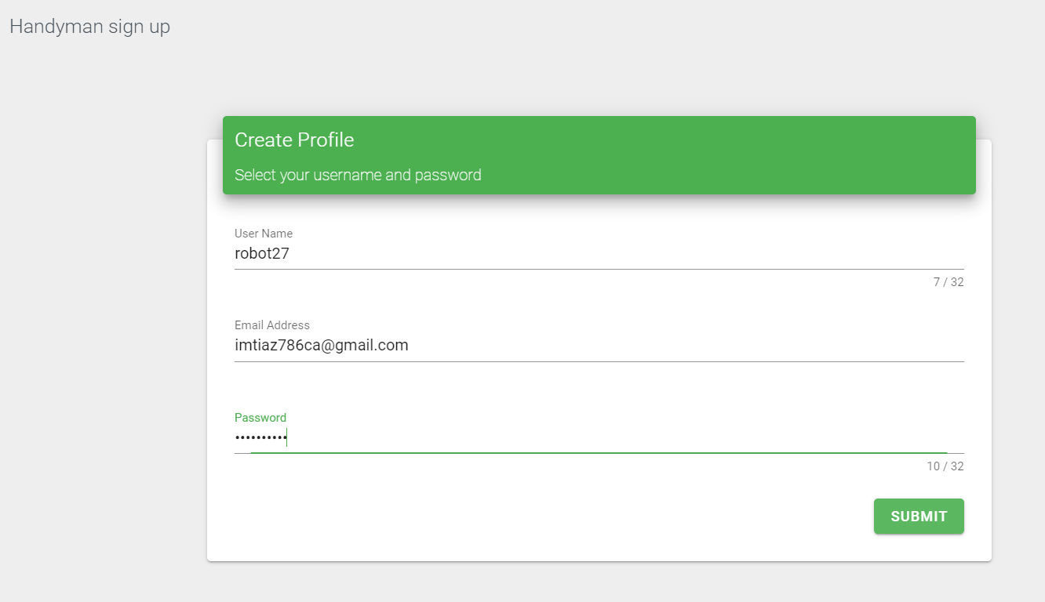

Fig 5.7 Showing 24 hour’s

1. Click Submit button and a new window will appear.

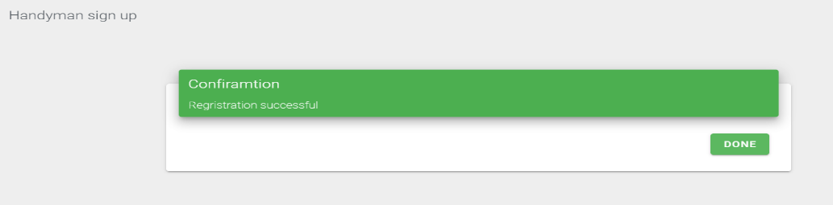

Fig 5.8 Registration Confirmation

1. You will back to home screen dashboard. Enjoy your browsing our application. Good Luck.



Fig 5.9 Home Screen of Handyman Application

# How can I log in Handyman Application as a handyman?

1. From handyman home screen, click sign in icon on the right top corner.



Click here for Sign in

Fig 6.1 Home screen sign in for handy man

1. A new screen will appear, insert your user name and password and click on sign button left corner.



Fig 6.2 login window for sign-in handy man application

1. button. After clicking it, a new window will appear, showing booking appointment, if any?

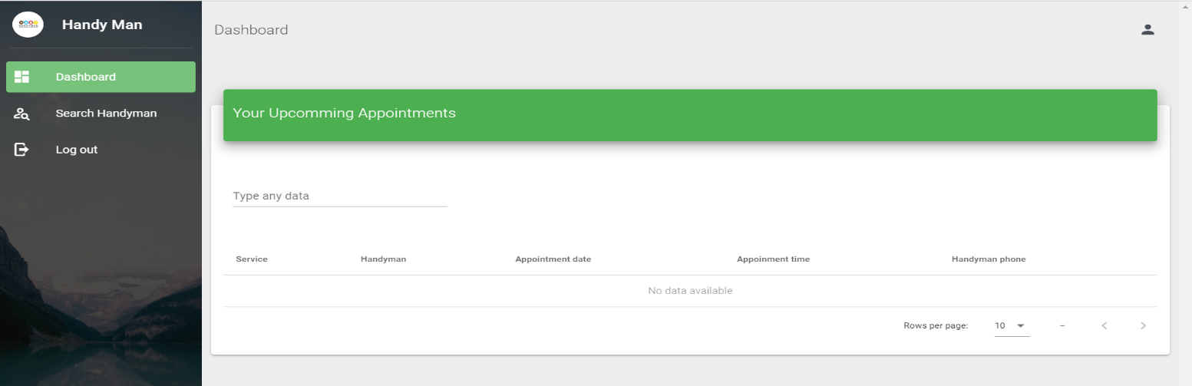

Fig 6.3 Dashboard showing booking status of handyman.

# How I know my booking Notification?

As handyman application work 2-way communication. As soon as, you booked by a homeowner, both party will received a email notification. Also, as a handy man, your dashboard collect that information.

-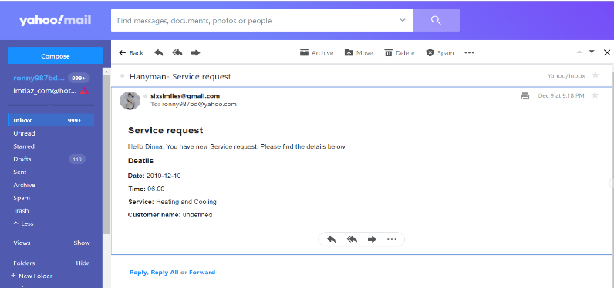

Detail service request from handyman application.

Fig 7.1 Email notification showing booking status of handyman.

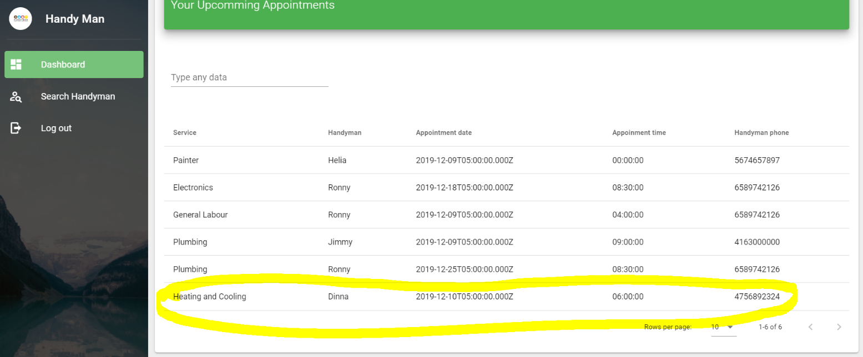

Fig 7.2 Dashboard showing booking status of handyman.

# Does handyman get Notification in email, too?

Yes, handy man and homeowner both will notify with email address more detail about booking time-table and phone number.



Fig 8.1 Notification email for handyman

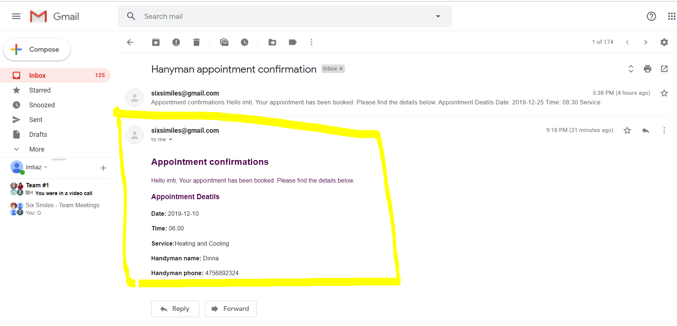

Fig 8.2 Notification email for Homeowner

# Question and Answers

# How handy man application protect consumer rights if any handy man neglected a job after booking?

Depends on the that trade license act handy man will be block from the system.

# Can I hire a handy man when I log in as a handyman?

Yes, depends on the job done on time, you can hair a handy man. Though you log on as a handy man.

# 

# Appendices

# Index

Job- name of the work

Trade- type of work or job category e.g civil construction, electrical, Plumbing, Heating And Cooling

Timescale- Duration of works

Rate- Work per hour

Trade/Skill License- Certification for the field of study

Carpentry- wood and wood related works

Electrical- domestic electrical house waring and fittings.

Electronics- Electronics device installation and maintenance

Mechanics- motor or electro mechanical works

Welder- welding jobs

Roofing- Roofing works for houses

Doors/Windows- Glass and light metal works

Heating/ Cooling – Air Conditioning - Boiler

Plumbing- bathroom fittings

Painting- interior -exterior painting